LAB EXPERIMENT RECORD

SET 28: VEHICLE PERFORMANCE ANALYSIS

Particulars | Details
Department | AIDS
Course Code / Course Name | DSA0206 / Data Handling and Visualization
Experiment | Data Visualization using R
Name | M.Teja kumar
Register Number | 192424308
Date | 15 OCTOBER 2026
Day | Thursday

Aim
To analyze vehicle performance by visualizing fuel efficiency across safety ratings, examining the relationship between horsepower and top speed, generating a correlation heatmap of numerical vehicle indicators, and outlining an interactive Tableau dashboard.

Dataset: Vehicle Performance
Vehicle ID | Engine Size (L) | Horsepower | Fuel Efficiency (km/l) | Top Speed (km/h) | Safety Rating
V1 | 1.5 | 110 | 18 | 180 | 4
V2 | 2.0 | 150 | 15 | 200 | 5
V3 | 3.0 | 250 | 12 | 250 | 5
V4 | 2.5 | 200 | 14 | 220 | 4
V5 | 1.8 | 130 | 17 | 190 | 3

PROGRAM 1: Violin Plot of Fuel Efficiency by Safety Rating
To compare the observed fuel-efficiency values for vehicles grouped by safety rating.
# SET 28 - PROGRAM 1
# Violin plot using base R

data <- data.frame(
Vehicle_ID = c("V1", "V2", "V3", "V4", "V5"),
Fuel_Efficiency = c(18, 15, 12, 14, 17),
Safety_Rating = c(4, 5, 5, 4, 3)
)

groups <- list( data$Fuel_Efficiency[data$Safety_Rating == 3],
data$Fuel_Efficiency[data$Safety_Rating == 4],
data$Fuel_Efficiency[data$Safety_Rating == 5]
)
group_names <- c("Rating 3", "Rating 4", "Rating 5") group_colors <- c("skyblue", "lightgreen", "orange")

plot(NA, xlim = c(0.5, 3.5), ylim = c(10, 20), xaxt = "n", xlab = "Safety Rating",
ylab = "Fuel Efficiency (km/l)",
main = "Fuel Efficiency by Safety Rating") axis(1, at = 1:3, labels = group_names)

for (i in 1:3) { values <- groups[[i]]
if (length(values) >= 2 && length(unique(values)) >= 2) { d <- density(values, from = 10, to = 20)
width <- d$y / max(d$y) * 0.3

polygon(c(i - width, rev(i + width)), c(d$x, rev(d$x)),
col = group_colors[i], border = "black")
}
points(rep(i, length(values)), values, pch = 19, cex = 1.2)
}

legend("topright", legend = group_names,
fill = group_colors, title = "Safety Rating")

Procedure: Create the vehicle data frame, group fuel-efficiency values by safety rating, draw the plotting region, then add violin shapes where a group has at least two distinct observations. The black points show the actual observations.
Observation / Result: Rating 4 vehicles have fuel-efficiency values of 18 and 14 km/l; rating 5 vehicles have values of 15 and 12 km/l; rating 3 has one vehicle at 17 km/l. Because the groups are very small, the plot cannot reliably estimate each group's distribution.
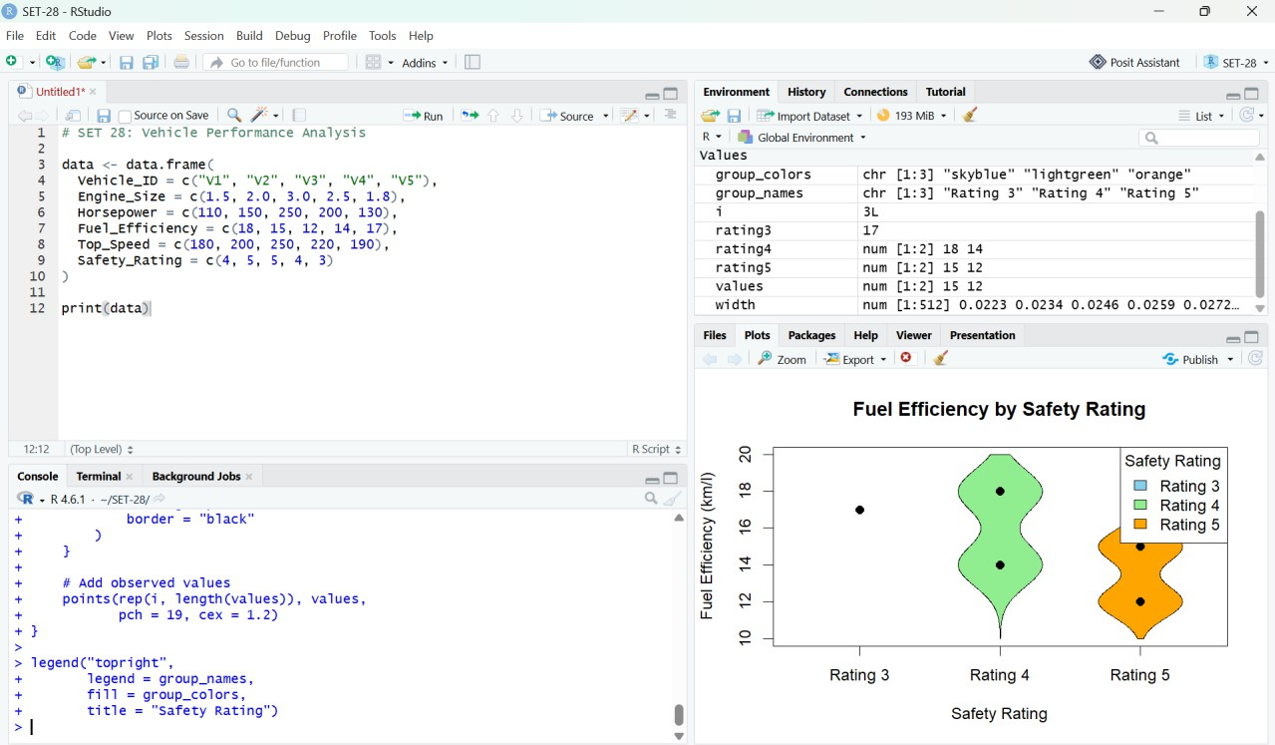
Figure 1. RStudio output: fuel efficiency grouped by safety rating.

PROGRAM 2: Scatter Plot of Horsepower vs Top Speed
To examine the relationship between vehicle horsepower and top speed using a scatter plot, regression line, and correlation coefficient.
# SET 28 - PROGRAM 2
data <- data.frame(
Vehicle_ID = c("V1", "V2", "V3", "V4", "V5"),
Engine_Size = c(1.5, 2.0, 3.0, 2.5, 1.8),
Horsepower = c(110, 150, 250, 200, 130),
Top_Speed = c(180, 200, 250, 220, 190)
)

plot(data$Horsepower, data$Top_Speed, main = "Horsepower vs Top Speed",
xlab = "Horsepower", ylab = "Top Speed (km/h)", pch = 19, col = "blue", cex = 1.4)

text(data$Horsepower, data$Top_Speed, labels = data$Vehicle_ID, pos = 3)

model <- lm(Top_Speed ~ Horsepower, data = data) abline(model, col = "red", lwd = 2)

correlation <- cor(data$Horsepower, data$Top_Speed) cat("Correlation Coefficient:", round(correlation, 3), "\\n") print(data)

Procedure: Plot horsepower on the X-axis and top speed on the Y-axis. Label each point with its vehicle ID, fit a linear regression model, draw the fitted line, and calculate Pearson's correlation.
Observation / Result: The correlation coefficient is approximately 0.997, showing a very strong positive linear association in this five-vehicle sample. Vehicles with greater horsepower generally have higher top speed; this small observational sample does not prove causation.
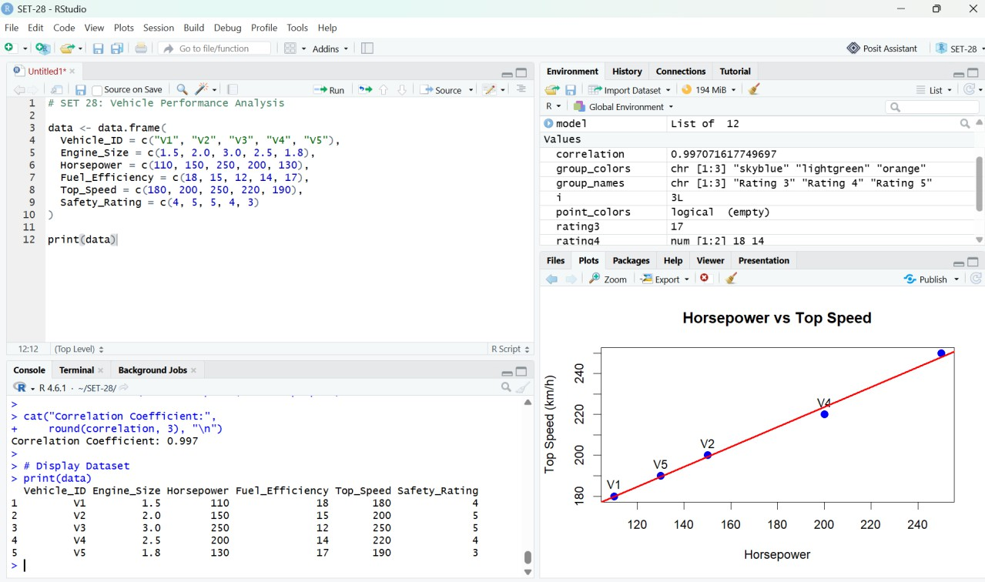
Figure 2. RStudio output: horsepower versus top speed with fitted regression line.

PROGRAM 3: Correlation Heatmap of Numerical Variables
To calculate pairwise correlations among engine size, horsepower, fuel efficiency, top speed, and safety rating and visualize them in a heatmap.
# SET 28 - PROGRAM 3
data <- data.frame(
Engine_Size = c(1.5, 2.0, 3.0, 2.5, 1.8),
Horsepower = c(110, 150, 250, 200, 130),
Fuel_Efficiency = c(18, 15, 12, 14, 17),
Top_Speed = c(180, 200, 250, 220, 190),
Safety_Rating = c(4, 5, 5, 4, 3)
)

cor_matrix <- cor(data) print(round(cor_matrix, 2))

heatmap( cor_matrix,
Rowv = NA, Colv = NA, scale = "none",
symm = TRUE,
col = colorRampPalette(c("blue", "white", "red"))(100), main = "Vehicle Performance Correlation Heatmap", margins = c(10, 10)
)

Procedure: Select the numerical variables, calculate the correlation matrix using cor(), print the rounded values, and use heatmap() to display the matrix. Blue indicates negative correlation, red positive correlation, and white values near zero.
Observation / Result: The heatmap indicates positive associations among engine size, horsepower, and top speed, while fuel efficiency is negatively associated with engine size and horsepower in this sample. With only five vehicles, the correlations are sensitive to individual observations and should not be generalized.
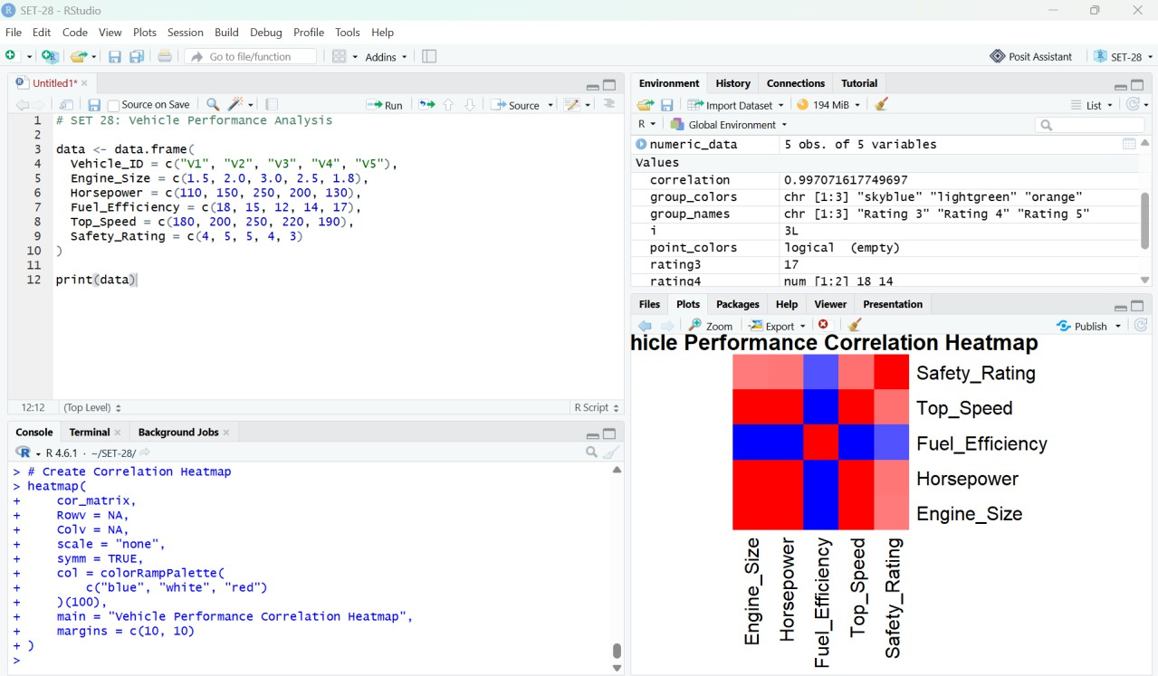
Figure 3. RStudio output: correlation heatmap of vehicle performance indicators.

PROGRAM 4: Interactive Tableau Dashboard
To create an interactive dashboard that combines a horsepower-versus-top-speed scatter plot with a fuel-efficiency chart.

Procedure
- Export the vehicle data from R to a CSV file using the code below.
- Open Tableau Desktop or Tableau Public and connect to Vehicle_Performance.csv.
- Create a worksheet named “Horsepower vs Top Speed”. Drag Horsepower to Columns and Top_Speed to Rows; choose Circle in the Marks card.
- Drag Vehicle_ID to Detail and Engine_Size to Color. Include vehicle ID and other vehicle details in the tooltip.
- Create a worksheet named “Fuel Efficiency by Vehicle”. Drag Vehicle_ID to Columns and Fuel_Efficiency to Rows; choose Bar and show labels.
- Create a dashboard and add both worksheets. Add filters for Engine_Size and Safety_Rating if desired.
- Set descriptive titles and tooltips, test the filters, and save the Tableau workbook.

Export CSV from R
write.csv(data, "Vehicle_Performance.csv", row.names = FALSE) getwd()

Result: The dashboard enables users to explore the association between horsepower and top speed and compare fuel-efficiency values by vehicle. Filters support interactive exploration of the small dataset.

Overall Procedure
- Create the vehicle dataset in RStudio.
- Run Program 1 to compare fuel efficiency by safety rating.
- Run Program 2 to plot horsepower against top speed and calculate correlation.
- Run Program 3 to generate the correlation matrix and heatmap.
- Export the dataset to CSV and create the interactive Tableau dashboard.

Overall Result
Vehicle performance was explored using a violin-style plot, a scatter plot with regression line, and a correlation heatmap. The supplied sample shows a strong positive association between horsepower and top speed, and negative associations between fuel efficiency and engine size/horsepower. An interactive Tableau dashboard can combine the scatter plot and fuel-efficiency chart. The findings are descriptive and limited by the five-vehicle sample.

